ShinyR GUI design and functionality Introduction II
This version solves the ‘fixed variables’ issue in the first version. There are two experimental features in shiny package: renderUI() and Binding inputs or outputs with JavaScript. This version uses renderUI() experimental functionality, which provides dynamic gui for input variables and target, as well as specific model options.
RenderUI is able to put dynamic widgets (the number and name of buttons are not known before launching the application) in either input side (sidebarPanel) or output side (mainPanel). Only that in each renderUI() function, only one widget can be handled. Thus this may take some work to design a complicated dynamic GUI.
This is how the data tab looks like: (left: load data from disk; right: load data from library) 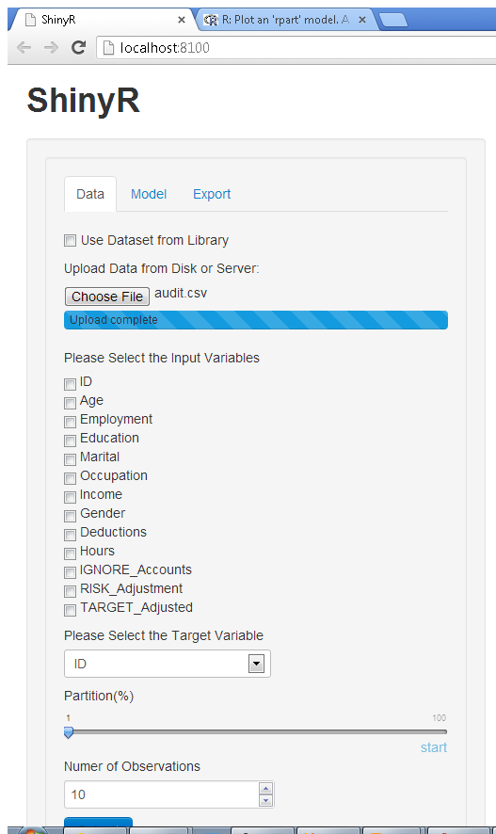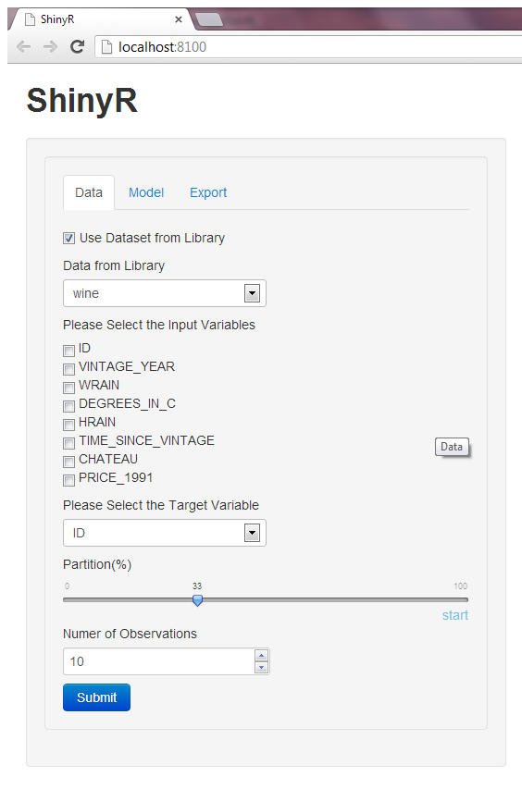
The model tan also uses rederUI() with conditionalPanel() to make each model options only available at the specific model type is selected. The number of the model types is also increased to six, including decision tree, random forest, svm, boost, regression, neural net.
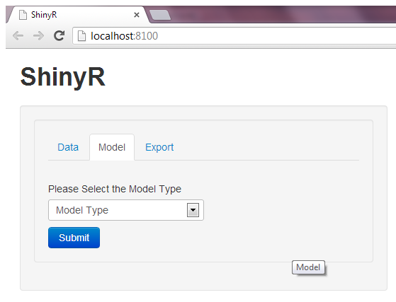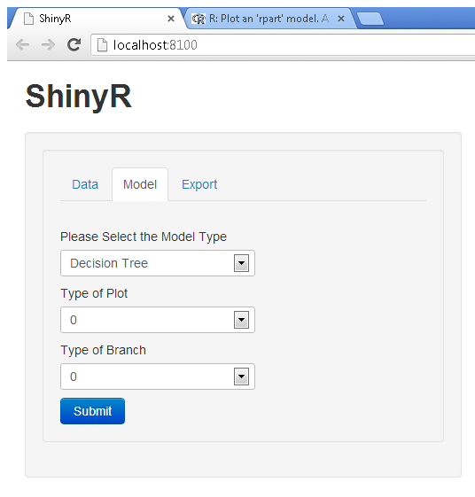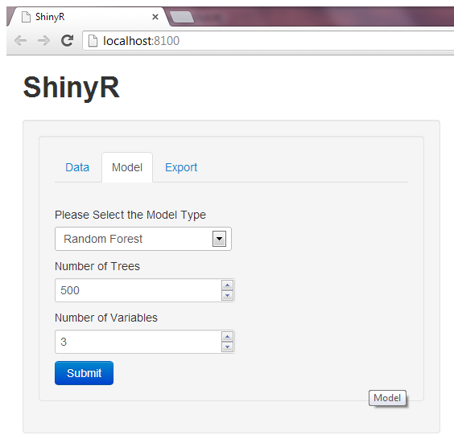
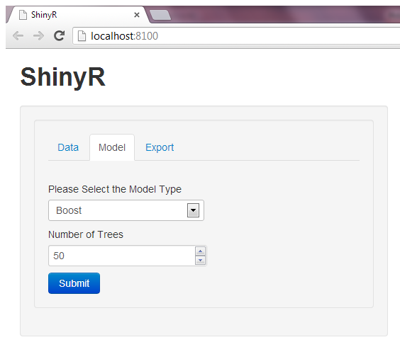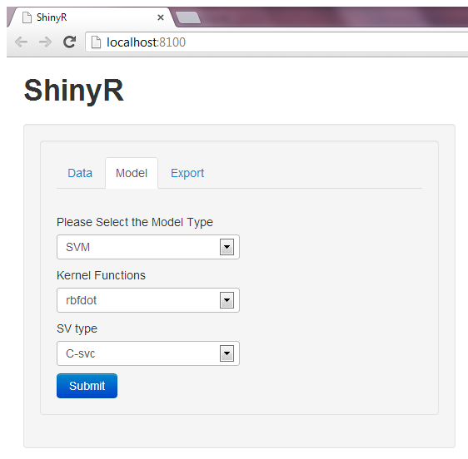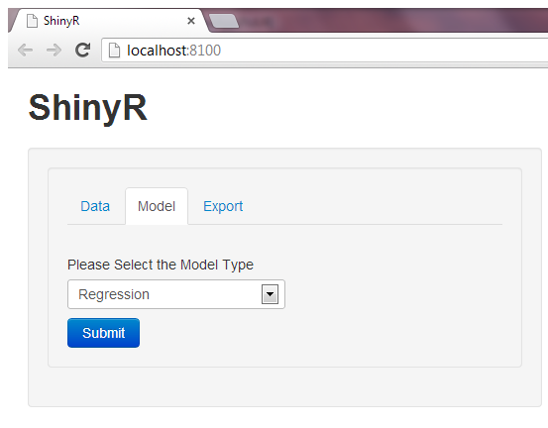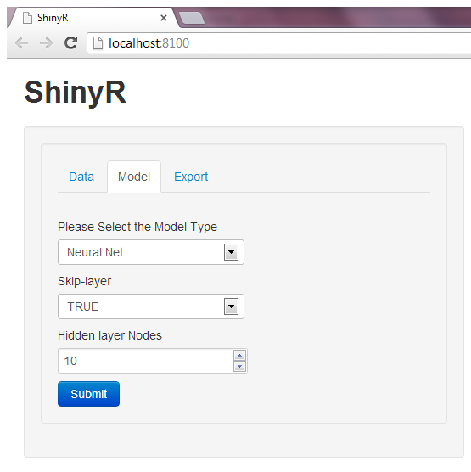
JavaScript example:
Define an increment button before calling ShinyUI and link it with the JavaScript and shiny binding script:
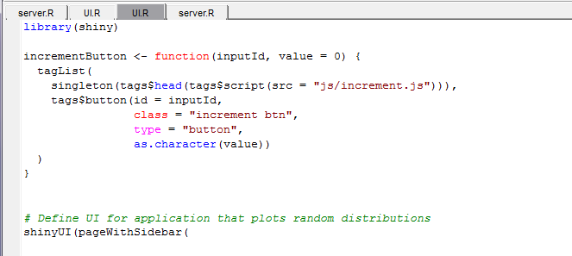
Call the increment button inside the shinyUI:
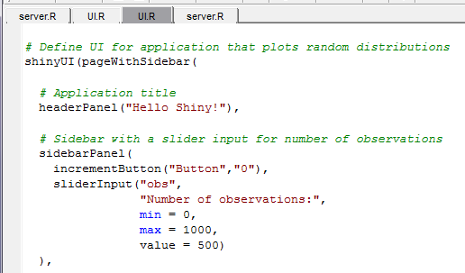
The number on the button will be increase upon each click after launching the application. The handler function of the JavaScript is used.
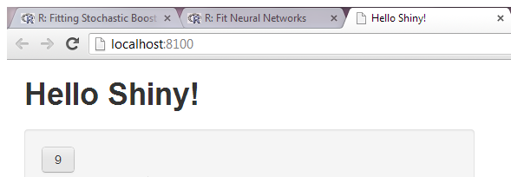
HTML UI: Instead designing the UI by ui.R, on can use html file to describe the website designs. The server.R can keep the same as long as the button IDs are consistent.
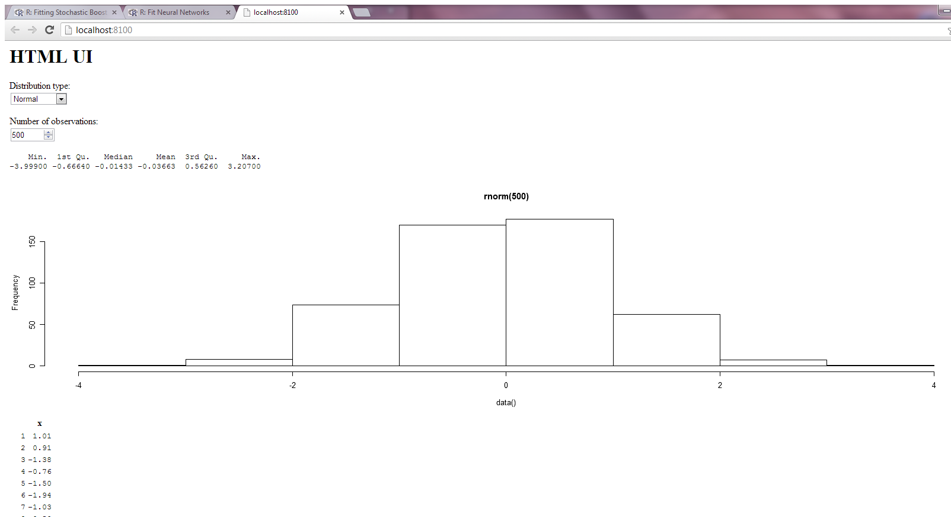
Add the JavaScript directory under <head> of the HTML file, and place it after calling shiny.js:
